ResourceTbl Table (I m using Oracle and Sql Developer Client)
- CREATE TABLE Statement
CREATE TABLE ResourceTbl
(
ResNo varchar2(8) CONSTRAINT ResNoabsent not null,
ResName varchar2(50) CONSTRAINT ResNameabsent not null,
Rate decimal(10,2) CONSTRAINT Rateabsent not null,
CONSTRAINT resnoPK PRIMARY KEY (ResNo),
CONSTRAINT rateCheck CHECK (Rate > 0)

);

- Run the above command
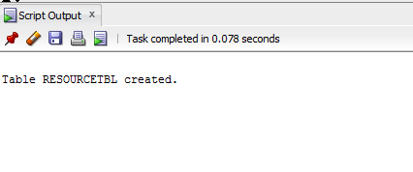
- Insert rows into it

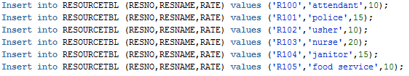

- Table data
